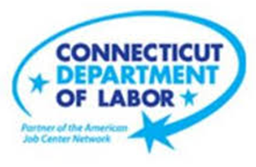

**NEW WEEKLY JOB POSTINGS FROM   
HELP WANTED ONLINE  
Office of Research**

**Week Ending June 4th, 2022: New Ads Down 30% over the week but up 9% from a year ago**WETHERSFIELD, June 10rd, 2022 – During the week ending June 4th, there were 6,847 new postings, down 2,992 new ads or -30% over the week. Three Industries comprised a combined third of this overall drop; Finance & Insurance, Health Care & Social Assistance, and Accommodation & Food Services. Employers with the largest over-the-week drop include Starbucks Coffee (-136 new ads), Deloitte (-114 new ads), and Yale-New Haven Health System (-85 new ads). The most recent weekly total is the lowest level since mid-April and the 5th lowest level of 2022. The one week change of -2,992 is the largest one week drop since the last week of December 2021, which was down 3,323 from a week prior. Though down over the week, total new ads are up 9% from a year ago. During the week of June 5th 2021 there were 6,294 new ads and during the week of June 6th 2020 there were 4,326 new ads. During the pre-pandemic first week of June 2019, there were 2,760 total new ads.  
  
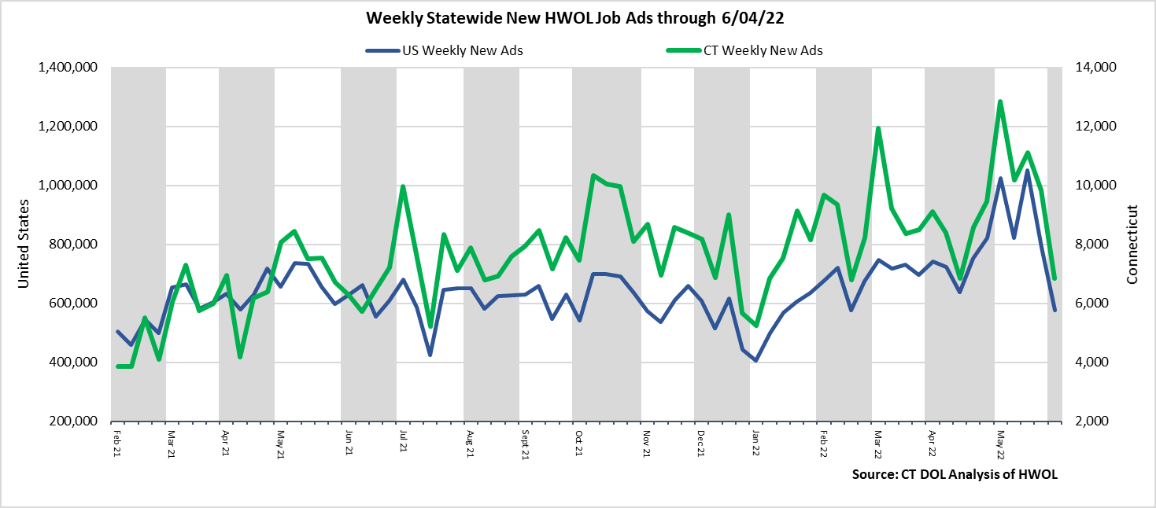  
**Industries** with the most new postings include Health Care & Social Assistance, Finance & Insurance, and Retail Trade.

**Occupations** with the most new postings include Registered Nurses, Retail Salespersons, Wholesale & Manufacturing Sales Representatives.

**Employers** with the most new postings include Yale-New Haven Health System, UnitedHealth Group, and Hartford Healthcare.

**The three industries with the most new job postings were:**

* **Health Care & Social Assistance** (1,336 new postings, -18% over the week)
* **Finance And Insurance** (691 new postings, -39% over the week)
* **Retail Trade** (648 new postings, -24% over the week)

   
 During the week ending June 4th, the total ad decrease of -2,992 or -30% is the net result of declines in 20 out of 21 industries. The largest over the week drops occurred in Finance & Insurance (-438 new ads or -39%), Health Care & Soc. Asst. (-302 new ads or -18%), and Accommodation & Food Services (-262 new ads or -41%). Among the 21 industries, the only over the week increase occurred in Transportation & Warehousing (+33 new ads or +17%). Over four weeks all but one industry had declines, the largest occurred in Health Care & Social Assistance (-744 new ads or -36%) and Finance & Insurance (-718 new ads or -51%). Over four weeks the only industry without a decline was Management, which was unchanged.   
  
For more information on total job ads by industry for Connecticut and its labor market areas, see the monthly report available here: <https://www1.ctdol.state.ct.us/lmi/hwol.asp>

**New Job Postings by Occupation** 

**The occupations with the most new postings were:**

* Registered Nurses (394 new postings, -7% over the week)
* Retail Salespersons (167 new postings, -43% over the week)
* Wholesale & Manufacturing Sales Representatives (154 new ads, -23% over the week)

**Employers with the Most New Job Postings**

Employers with the most new job postings during the week were mostly in Retail Trade, Health Care, and Finance & Insurance. The 25 employers shown above account for 19 percent of all new ads. Among the top 25 employers, 15 had over the week ad increases and 10 had decreases. The largest top 25 employer increase over the week was Trellix Incorporated (+86 new ads), Amazon (+58), and Marrakech Inc (+52 new ads). The largest decreases in the top 25 include Yale-New Haven Health System (-85 new ads), PricewaterhouseCoopers (-69 new ads), and Capital One (-51 new ads).   
  
**What is HWOL?**The **Conference Board Help Wanted Online**® Data Series (HWOL) measures the number of new, first-time Online job postings and jobs reposted from the previous month for over 16,000 Internet job boards, corporate boards and smaller job sites that serve niche markets and smaller geographic areas. To view more HWOL data, go to: <https://www1.ctdol.state.ct.us/lmi/hwol.asp>